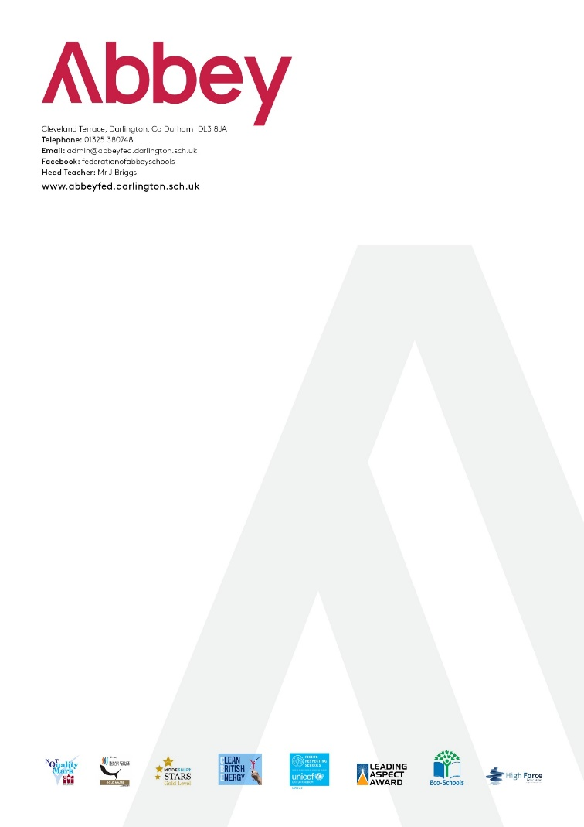

**Human Resources Report – June 2023**

**Staffing**

|  |
| --- |
| **Leavers:** |
| * 2 x Catering Assistant (10 hours x 2) * 1 x Teacher |
| **New appointments:** |
| * 1 x Catering Assistant (10 hours x 2) * 1 x Breakfast Club assistant positon of 1.5 hours – existing member of staff |
| **Maternity Leave:** |
| * 1 TA and 1 Teacher |
| **Changes to contract:** |
| * 1 x Assistant Catering Manager increased from 15.75 to 16.75 to allow for admin time |
| **Long term sick:** |
| * 1 x TA   Absence is monitored closely in line with our Absence Management Policy. Procedures are in place to notify staff when absence triggers are hit, and when absence improvement plans should be put in place. |