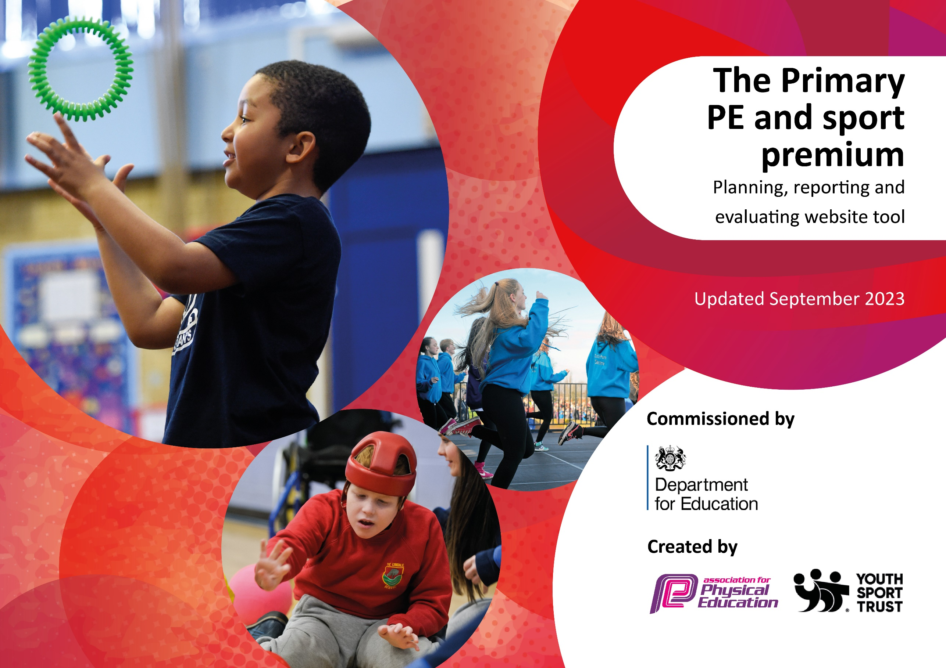

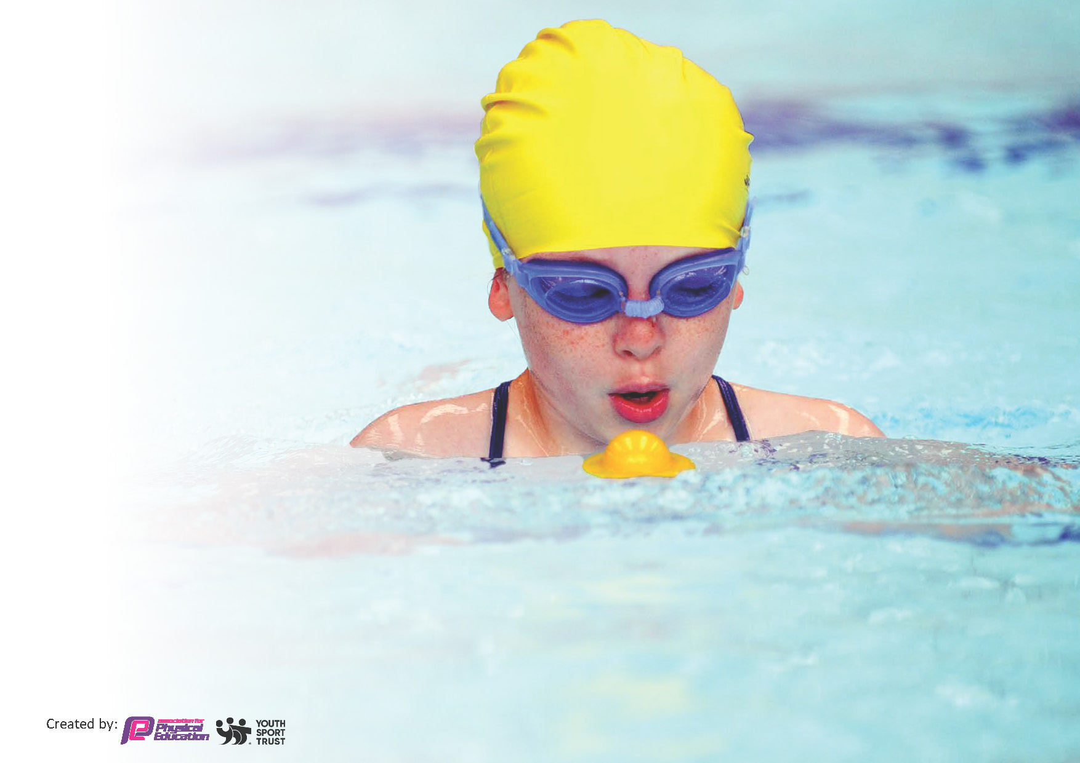
This template can be used for multiple purposes:
by:
- It enables schools to effectively plan their use of the Primary PE and sport premium
- It helps schools to meet the requirements (as set out in guidance) to publish information on their Primary PE and sport premium
- It will be an effective document to support Ofsted inspections enabling schools to evidence progress in Physical Education (PE) and evidence swimming attainment, which forms part of the PE National Curriculum. We would recommend schools consider
the Intent, Implementation and Impact of any spend, as examined within the Education Inspection Framework.

It is important that your grant is used effectively and based on school need.

Schools must use the funding to make additional and sustainable
improvements to the quality of the PE, School Sport and Physical Activity (PESSPA)
they offer. This means that you should use the Primary PE and sport premium to:

- Build capacity and capability within the school to ensure that improvements made now will benefit pupils joining the school in future years
- Develop or add to the PESSPA activities that your school already offers.

The Primary PE and sport premium should not be used to fund capital spend projects; the school’s core budget should fund these. Further detail on capital expenditure can be found in the updated Primary PE and sport premium guidance.

The Primary PE and sport premium guidance, outlines 5 key priorities that funding should be used towards. It is not

necessary that spending has to meet all the key priorities, you should select the priorities that you aim to use any funding towards.

Although completing this template is not a requirement for schools, schools are required to publish details of how they spend this funding. Schools must also outline what the impact this funding has had on pupils’ PE and sport participation and attainment and how any spending will be sustainable in the future. All funding must be spent by 31st July 2024.

The Department for Education has worked closely with the Association for Physical Education (afPE) and the Youth Sport Trust (YST) to develop this template and encourages schools to use it. This template is an effective way of meeting the reporting requirements of the Primary PE and sport premium.
Review of last year’s spend and key achievements (2024/2025)

We recommend you start by reflecting on the impact of current provision and reviewing your previous spend.

Activity/Action | Impact | Comments
Platinum School Games Mark  The sports leader ensured that throughout the year the gold targets were met, which allowed our school to further apply for the platinum mark.  Participated in inter-school competitions provided by Darlington Schools Sports partnership:  25 Competitions  14 - 1st place finish  3 - 2nd place finish  6 - 3rd place finish  5 Tees Valley qualifications  1 - 1st place finish  2 – 2nd place finish  2 – 3rd place finish  6 SEND/festivals  2nd place at the Year 4 St Augustine’s Football Shield  1st place in the Year 5/6 girls Darlington Football League  2nd place in the Year 5 Darlington 5 a-side Football Competition  891 children participated in 9 intra-school competitions organised by the sports leader.  Purchasing more football goals.  The sports leader delivered sports clubs offered to all KS2 children each morning and four after school clubs. Two external providers were hired to provide football and dance to KS1 and KS2 children.  Continuing to provide high quality PE lessons through the sports leader and teachers. Teachers received CPD via sports leader and external coaches leading lessons.  Sensory Circuits was established for children who were identified as the least active, struggled with their physical literacy, and were on a provision mapping for Special Educational Needs. | All children were exposed to the gold mark criteria targets: active 60 minutes, inclusion, physical literacy and positive experiences, student engagement, intra and inter- school competition, culture and youth engagement. This led to a more broad, inclusive curriculum being offered and a wider engagement in sport across the whole of the school community.  Many children for all KS2 year groups have had the opportunity to represent Abbey school in inter-school competitions in a wide range of sports. All children have received training from the sports leader in the build up to each event.  SEND children have had the opportunity to participate outside of school in a noncompetitive environment. These opportunities increased the children’s confidence and well-being.  All KS2 children were able to compete in different sports and achieve their personal best.  Children had more opportunities to participate in football with their friends and be more active. Children who would not normally play football started to get involved and over 60% of KS2 children were playing every breaktime. This supported the active 60 minutes.  Over 400 children in the 2024/25 academic year accessed these clubs. This helped children achieve the active 60 minutes a day and improved mental health and fitness.  Teachers’ subject knowledge and confidence increased. The children’s enjoyment of sport increased.  The circuits incorporate sensory-based movement activities that prepare children and young people for learning throughout the day. They help achieve the optimal level of alertness needed for concentration and increase the children’s physical literacy. | We will continue to meet these targets and achieve the School Games platinum award.  This is an ongoing commitment.  This is an ongoing commitment.  Due to the number of children wanting to participate in football we are planning to purchase more goals and have lines painted on the field.  The sports leader’s feedback from staff was that the children were more alert and focused in the morning and their skill and confidence increased.  Teachers will continue to follow GetSet4PE scheme and adapt and change for the needs of their class.  The program will continue to consist of approximately 15-20 minutes of activities, conducted three times a week in the morning.

Key priorities and Planning
This planning template will allow schools to accurately plan their spending.

Action – what are you planning to do | Who does this action impact? | Key indicator to meet | Impacts and how sustainability will be achieved? | Cost linked to the action
Maintain daily sporting activities which are made available to all children at break time and lunchtime.  The sports leader will run sports clubs every morning and after school offering a wide range of sports.  Each class will have access to 2 high quality PE lessons a week.  Purchase and replace PE equipment to use throughout school.  Use the reporting tool on GetSet4PE to record and track physical activity.  Continue to run sport interventions for targeted children (MAPP plans, difficulty with physical literacy, behavior needs and classroom withdrawal)  Weekly swimming lessons in Year 4 and catch-up swimming lessons for Y5/6 children.  PE leader to follow the success criteria for the School Games gold award.  PE leader to offer all children regular intra-school competitions, personal best sessions and strength and conditioning sessions.  Increase opportunities for children to participate in a wider range of inter-school competitions and festivals offered by Darlington school Sports Partnership.  Provide sports that less active children enjoy by offering broader experience of a range of sports and activities offered to all pupils e.g. dodgeball, handball, frisbee golf, bike ability. We will send out a pupil voice questionnaire to gauge children’s opinions on the sports they want to be on offer.  Renewal of getSet4PE scheme  External coaching service will work alongside teaching staff and supports staff to deliver PE lessons to upskill and provide CPD for staff.  Sports Leader will work individually with teachers to support specific areas on which they would like to improve in.  PE Lead to seek feedback on what CPD teachers want now and in the future.  PE lead to observe KS2 staff  to monitor delivery of PE across the school.  A curriculum map will be developed for each year group. Teachers can access lesson plans for the half termly topics.  A sports club will run each morning, offered by the sports leader which children will have the opportunity to participate in a wide range of sports.  The sports leader will also organize activities during break time and lunchtime offered to all children.  Children will have the opportunity to participate in a range of inter-school competitions/festivals offered by DSSP.  SEND children will be able to take part in SEND inclusive festivals and events offered by Tees Vallet Sport and DSSP.  Darlington Council to deliver bike ability and learn to ride.  Sports leader will continue to deliver the NFL curriculum.  Barclay’s Girls Football will run all year. (promotion of girls football)  Introduce a new sport (nerf wars or Quidditch)  Taster days for non-traditional sports along with alternative sports festivals.  Specific SEND PE lessons.  Children will be offered session with Darlington Table Tennis Club at Hummersknott Academy.  Sensory Programme  Darlington SSP membership.  To take part in the vast majority of competitions, festivals and SEND inclusion events Darlington SSP will offer. We will take B and C teams where possible. B and C team will be children who have not taken part in an inter-school competition.  Children will take part in the St Augustine’s Football Competition.  Children to take part in the Paul Bielby Football League.  The sports leader will run intra-school events throughout the year.  PE lead to organise personal challenges in PE lessons. | All pupils, as they take part.  Lunchtime supervisors who will be leading the activity.  Teaching staff.  Playleaders/Sports organising crew, as they will be leading the activity.  All pupils and staff will further develop an awareness of the importance of PE and physical activity.  PE leader will be given time to complete information and evidence to complete the School Games mark.  All teaching staff - increase their confidence and knowledge of PE curriculum and the skill of delivering progressive, differentiated PE lessons.  Pupils – will receive high quality PE sessions.  Teaching staff  All children are to be offered access to a broader range of sports.  Year 5 and Year 6 children.  Year 5 and Year 6 children.  All girls.  All children.  All children.  NG children.  Year 5 and Year 6 children.  All children who meet the criteria to take part in the SMART programme (designed to work on children’s gross and fine motor skills) 3 times a week.  All children who participate.  Year 4 children.  The boys’ and a girls’ team that take part.  All children who participate.  The children who participate. | Key indicator 1: The engagement of all pupils in regular physical activity – Chief Medical Officer guidelines recommend that primary school children undertake at least 60 minutes of physical activity a day in school.  Key indicator 2: The profile of PE and sport being raised across the school as a tool for whole school improvement  Key indicator 3: Increased confidence, knowledge and skills of all staff in teaching PE and sport  Key indicator 4: Broader experience of a range of sports and activities offered to all pupils  Key indicator 5: Increased participation in competitive sport | More pupils will engage in physical activity on a regular basis (at least 60 minutes of physical activity a day).  Reporting each class will allow us to easily see and target certain children and ensure that all children are engaging in physical activity.  In 2024/2025 there were 25 Y6 Sports Leaders, and their confidence increased throughout the academic  year. They supported groups from Y3 to Y6 at breakfast clubs, ASC and lunchtimes.  Children’s confidence and well-being will improve from the interventions.  The percentage of children who meet the curriculum requirements for swimming and water safety will improve.  More children will be confident swimmers.  Abbey School has achieved the Gold award 5 years in a row. In 2024/25 we have been awarded the platinum award.  Children view PE as a high priority and value all aspects of sport.  Abbey School has a dedicated sports Facebook page where all aspects of sport is shared with parents and the community.  The percentage of children overall who are participating in sport will increase.  Intra-school competitions will motivate children and allow more children to take part in competitive sports.  Children’s progress in a range of skills shows improvement over time using a range of personal best challenges.  Motivates children to try their best. Sport Star certificates and School Games certificates were handed out in lessons to promote the School Games values and to celebrate the children displaying these attributes.  More children will meet the target of daily 60 minutes of physical activity.  Increased knowledge and  confidence of staff.  Teachers will have improved  knowledge, which will help them to deliver and adapt high quality PE lessons.  Children’s enjoyment of PE will rise due to staff feeling more confident and organized in lessons. Also, the children health and well-being will increase.  Increased participation in physical activity throughout school. Engaging children to achieve 60 minutes of daily activity.  Children enjoy a varied range of sports and possibly exit routes from school into outside clubs.  Greater attendance of children who are reluctant to normally participate in sports.  Children will be able to compete in competitive sports.  Children will be able to represent Darlington in reginal finals.  Children will start to learn basic control and balance, all the way to planning and making independent journeys on roads.  Children will be exposed to the NFL programme that displays qualities and characteristics of respect, integrity, resilience and responsibility.  An increase in girls taking up football for the first time. Also, there will be an increase in girls who want to continue playing football.  Children will be exposed to a wide range of sports outside of the Pe curriculum. There will be exit routes to extra-curricular clubs.  All SEND children in KS2 have had an opportunity to take part in intra-school competitions and personal challenges.  SEND children will have the benefit of specific activities that will help support their physical needs and promote a positive wellbeing and safe environment.  The sports leader will keep in contact with MR Pontone, and continue to the external link with the club.  Staff will continue to run the programme and include any other children who meet the needs and require additional support. CPD will be offered to staff when and if needed.  Children will continue to take part in competitive and non-competitive sports.  Number of events attended increases therefore the number of children participating increases  Abbey School has taken part in 32 inter-school competitions in 2024/25. 82% of Year 4,5 and 6 children have attended a competition, event or festival.  Six of the inter-school competitions were pathway events in which Abbey School finished in the top 3 five times.  Children will be engaged and motivated in football to compete at a high level. In 2024/25 Abbey school finished 2 in 2nd place.  The girls’ team in 2024/25 qualified for the Champion of Champions and finished in 1st place.  Children will be able to compete with and against their peers.  Intra-school competitions will help children build confidence, teamwork skills whilst having fun.  KS2 have taken part in 9  intra-school competitions with  891 participations in 2024/25.  Lessons were adapted to ensure that all children achieved their person best. | £7540 cost for sporting futures who will be delivering PE sessions.  £1250 new sports equipment  £1090 to cover top up swimming lessons.  £1500 cost for DSSP SLA.  Run by sports coach before and after school  £3040  £585 GetSet4PE membership  GoWell – external coaching for staff/children  £2545  Coaching for teaching staff in curriculum time to upskill new staff and staff that have changed year groups  £3450  Sports coach to run the festivals and train the children  £950  Level 2 Bikeabilty offered £750  Sports coach to run the sessions and train staff in curriculum time £1600  £800 for new sports equipment  Taster days organized by the sports coach with new equipment and inter school competitions  £1000  Training for staff and new equipment  £700  £2000 DSSP SLA and part fund transport  Sports coach to run breakfast, lunch and after school clubs to train and prepare children for events  £3450  120 Paul Bilby football affiliation.  Sports coach to train and run intra school competitions  £3500

Key achievements 2025-2026
This template will be completed at the end of the academic year and will showcase the key achievements schools have made with their Primary PE and sport premium spending.

Activity/Action | Impact | Comments

Swimming Data
Meeting National Curriculum requirements for swimming and water safety.
Priority should always be given to ensuring that pupils can perform safe self-rescue even if they do not fully meet the first two requirements of the National Curriculum programme of study

Question | Stats: | Further context  Relative to local challenges
What percentage of your current Year 6 cohort can swim competently, confidently and proficiently over a distance of at least 25 metres? | % | Use this text box to give further context behind the percentage.  e.g., 30% - we are struggling to get pool space due to our local pool closing so we have had to use a much smaller local school pool. We have had to limit the number of pupils attending swimming lessons during one term which means some pupils have attended fewer swimming lessons than others.
What percentage of your current Year 6 cohort can use a range of strokes effectively [for example, front crawl, backstroke, and breaststroke]? | % | Use this text box to give further context behind the percentage.  e.g., Even though your pupils may swim in another year please report on their attainment on leaving primary school at the end of the summer term 2024

What percentage of your current Year 6 cohort are able to perform safe self-rescue in different water-based situations? | % | Use this text box to give further context behind the percentage.
If your schools swimming data is below national expectation, you can choose to use the Primary PE and sport premium to provide additional top-up sessions for those pupils that did not meet National Curriculum  requirements after the completion of core lessons. Have you done this? | Yes/No
Have you provided CPD to improve the knowledge and confidence of staff to be able to teach swimming and water safety? | Yes/No

Signed off by:

Head Teacher: | (Name)
Subject Leader or the individual responsible for the Primary PE and sport premium: | (Name and Job Title)
Governor: | (Name and Role)
Date:

